Enabling Career Site Builder and Configuring the Data Center Information
Objectives
After completing this lesson, you will be able to:
- Enable Career Site Builder.
- Configure the Recruiting Marketing Data Center URLs.
- Enable Mobile Apply.
Recruiting Command Center
Before working within Career Site Builder (CSB), first, an integration must be created between the SAP SuccessFactors Recruiting system (which hosts the recruiting Applicant Tracking System) with Recruiting Command Center (which hosts the career site). Command Center is a backend application used to manage Career Site Builder tenants, just like Provisioning is the backend application for all SAP SuccessFactors applications. All Command Center configurations must be done by a consultant (or SAP) as customers do not have access to Command Center.
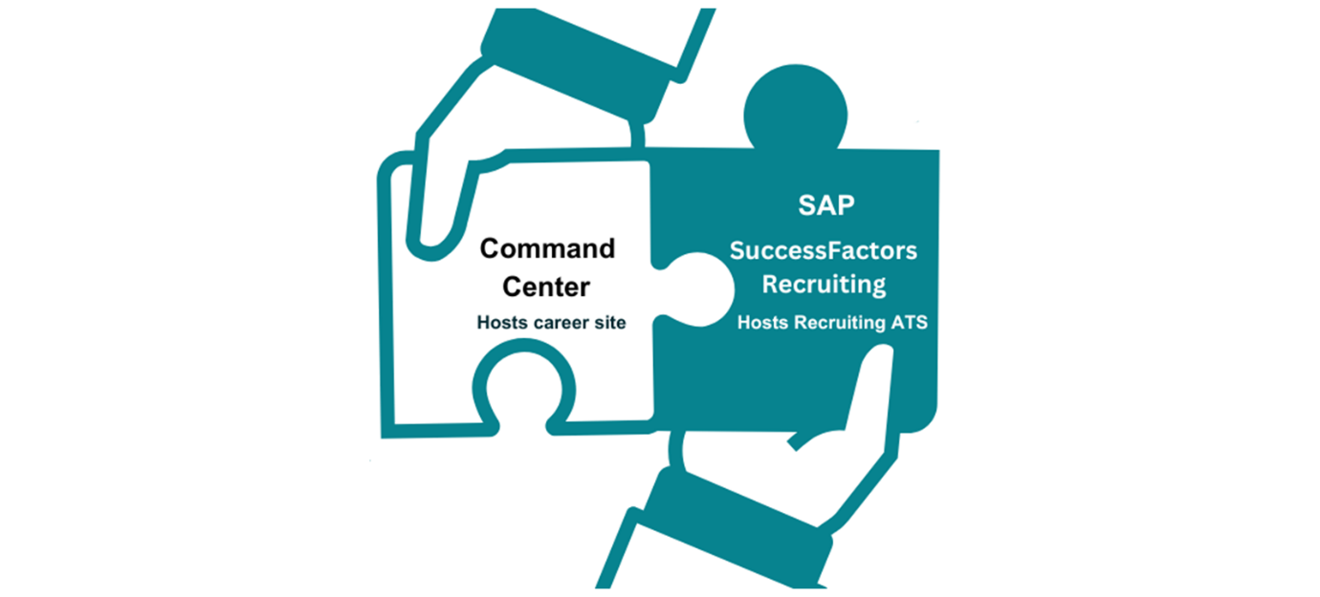
Before configuring the integration between SAP SuccessFactors Recruiting and Command Center, it is recommended that you familiarize yourself with accessing Command Center, its pages, and functions.
Command Center URLs
Command Center has two environments: Stage/Preview and Production. While Stage/Preview is used for building a career site before it goes live, Production hosts the live career site environment.
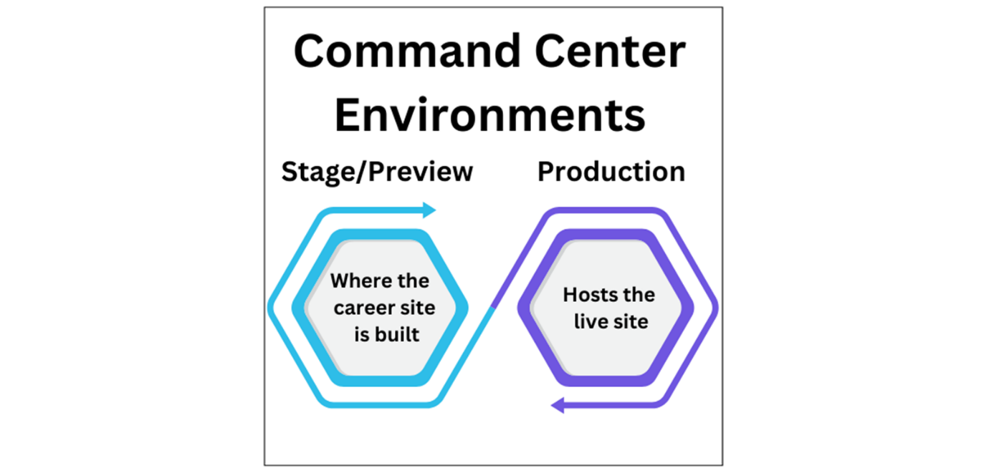
Within the Command Center URL, the environment as well as the Data Center can be identified.
Use the following format to log in, where <Data Center> is the Data Center number:
- Stage/Preview – https://bizx<Data Center>.stage.jobs2web.com/commandcenter
  - Data Center 12 stage example: https://bizx12.stage.jobs2web.com/commandcenter
  - Rackspace stage: https://bizx.stage.jobs2web.com/commandcenter
- Production – https://bizx<Data Center>.jobs2web.com/commandcenter
  - Data Center 12 production example: https://bizx12.jobs2web.com/commandcenter
Login Credentials
Logins are tied to SAP user credentials (I-, D-, or S-User ID), and are not Command Center-specific.
Command Center Site List Page
After logging in to the Site List page, you can filter on a number of fields to locate your customer’s site. Quick links are provided for Career Site Builder, the Career Site, and Recruiting Advanced Analytics.
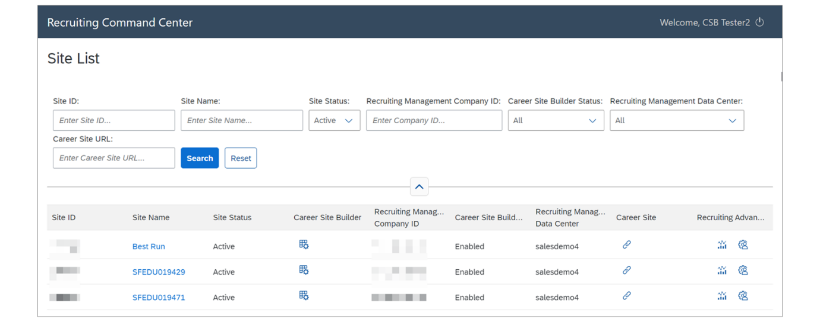
Command Center Site Details Page
The following are enabled on the Site Details page:
- Status of the career site
- Career Site Builder
- Use of multiple ATS
- Folder Name (this field is auto populated by the system and should not be changed)
On the right side of the screen, a section for Additional Options is available to access logs and to inactivate all jobs on the career site.
Inactivate All Jobs performs a "hard reset". Use this after you add or change job field mapping, or a field on the job requisition template. Afterwards, restore all jobs with a job sync.
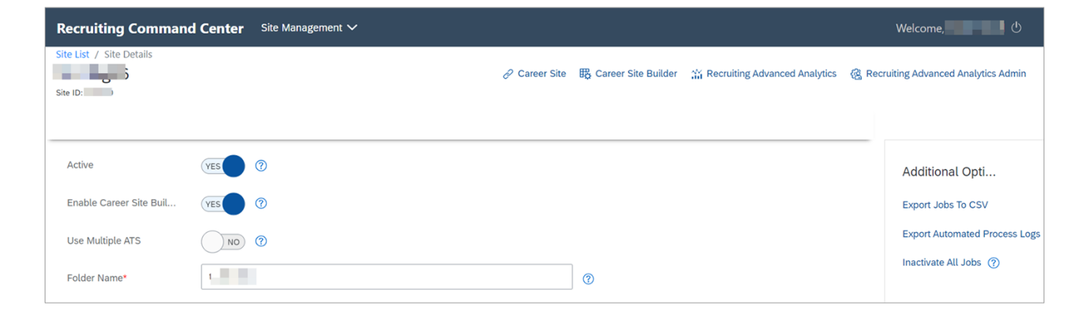
Command Center Feeds Management
Within the main dropdown menu at the top of Command Center, you can switch to the Feeds Management page. This is where you can create and generate XML feeds (standard or custom) based on the customer’s job distribution requirements.
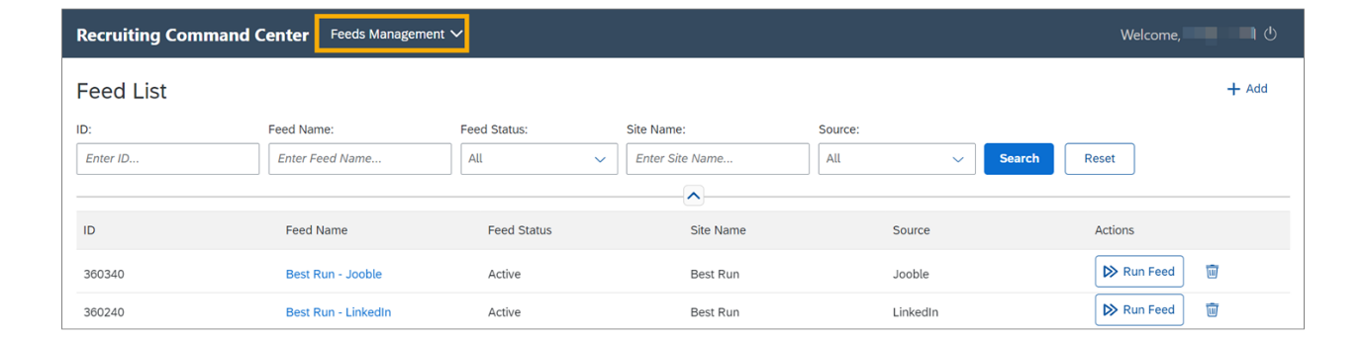
Enable Career Site Builder in Provisioning
Before an integration can be configured, first, you must enable Career Site Builder in Provisioning. Proceed as follows:
Steps
- Log in to Provisioning and navigate to Company Settings.
- Enable Recruiting Marketing.
- Select the following: Enable Job Marketing, Enable Career Site Builder, and Enable Candidate Account Simplification.
- Select Save.

Enable Career Site Builder in Provisioning
This video provides a demonstration of how to enable Career Site Builder in Provisioning.
Note
Currently, there is no SAP Learning System access available for this course. When available, reference the exercise demo videos to view a demo of the system.
Business Example
You begin the site setup by enabling Career Site Builder in Provisioning.
Steps
- Log in to your Provisioning account.
- Navigate to Company Settings, and select Recruiting Marketing, Enable Job Marketing, Enable Career Site Builder, and Enable Candidate Account Simplification.
- Select Save.
Recruiting Marketing Data Center URLs
Once Career Site Builder is enabled, the integration between the two systems can begin.
First, you need to specify the Recruiting Marketing Data Center URLs within Provisioning. These are hosted in Provisioning, allowing the synchronization of recruiting data to be sent back and forth.

Within Provisioning, navigate to Managing Recruiting→Configure Recruiting Marketing Datacenter URL.
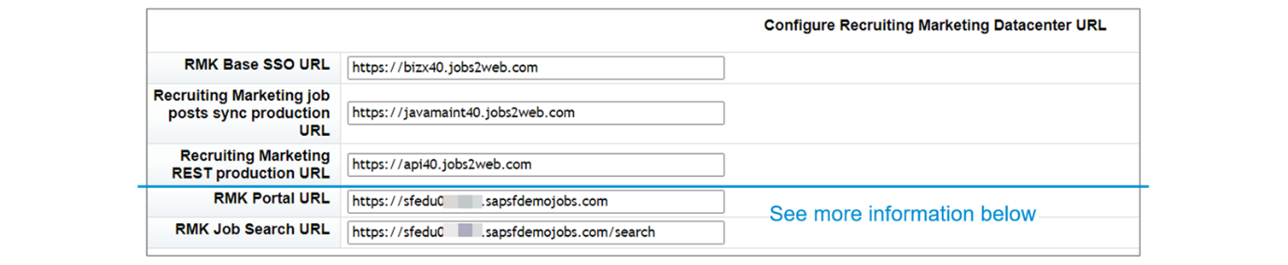
The following fields tell the SAP SuccessFactors HCM suite which Recruiting Marketing environment they’re connecting to.
- Recruiting Marketing Base SSO URL – the base address of the Recruiting Marketing services like Career Site Builder, job marketing and other various tools that are part of the Recruiting Marketing landscape but integrated with the SAP SuccessFactors platform for Session Management.
- Recruiting Marketing job post sync production URL – the base address for Job Synchronization. This field is also used for a variety of other backend calls that synchronize data between Recruiting Management and Recruiting Marketing.
- Recruiting Marketing REST production URL – used to synchronize candidate data between Recruiting Management and Recruiting Marketing.
The last two fields are specific to the customer's Recruiting Marketing career site URL and control items related to the candidate experience. You will need the site URL to complete the last two fields.
Consider the following when completing the Recruiting Marketing Portal URL & Search URL:
- The Recruiting Marketing Portal URL can be found in CSB→Settings→Site Configuration→Site Information (https:// will need to be added before the URL).
- Enter the same URL for Recruiting Marketing Job Search URL, with the addition of /search at the end.
Configure SAP SuccessFactors Recruiting Marketing Data Center URLs
This video provides a demonstration of how to configure the Recruiting Marketing Data Center URLs.
Business Example
Continue the site setup by configuring the URLs from the Recruiting Marketing data center.
Steps
- Within Provisioning, select the Company Name to navigate to Managing Recruiting→Configure Recruiting Marketing Datacenter URL.
- For the first three fields, enter the URLs provided in the Recruiting guide Recruiting guide.

- To complete other 2 fields, log in to Command Center, using the URL provided in the email you received for class with the subject: Your SuccessFactors HCM demo Recruiting Marketing instance is being prepared.
- Select the site name.
- Select the Career Site Builder quick link from the top of the page.
- For the Recruiting Marketing Portal URL field, enter https:// followed by the Site URL from CSB→Settings→Site Configuration→Site Information. As this is a training instance, we will need to create the Site URL with the Company ID.
  - For training instances, the Site URL should contain the Company ID followed by .sapsfdemojobs.com. For example, https:// sfeduXXXXXX.sapsfdemojobs.com. (We will be adding .sapsfdemojobs.com in the site URL hosted in Career Site Builder during a later exercise.)
  - In training instances, the alphabetical characters in Company ID referenced in the last two fields must be in lowercase.
- For the Recruiting Marketing Job Search URL, enter the same URL as the Recruiting Marketing Portal URL, with the addition of /search at the end.
- Select Save.
Administrator Permissions
Thus far, we have been accessing Career Site Builder from Command Center, which provides access to Career Site Builder with all permissions. However, it is best practice to provide role-based permissions to the admin and Recruiting users to access Career Site Builder through Admin Center. The following permissions are required.
We will set user permissions for:
- Manage Recruiting→Manage Career Site Builder – to access CSB
- Manage Recruiting→Setup Recruiting Marketing Job Field Mapping – to set up field mapping for Real Time Job Sync
- Recruiting Permissions→Recruiter RMK SSO – to access CSB or Advanced Analytics
- Recruiting Permissions→Job Marketing – to access Recruiting→Source Tracker
Note that in addition to admins, recruiters will also need appropriate role-based permissions, for example, to access the Source Tracker. Later, we will set roles within Career Site Builder, to restrict permissions for users who have access to CSB.
Note that it is leading practice is to create "dummy users" so that when an admin leaves, other admins can still perform tasks and provide permissions for other admin users. Examples:
- SF Admin – super admin for the Recruiting system
- CSB Admin – admins for Career Site Builder
Update Email Addresses for Recruiting Users
This video provides a demonstration of how to update email addresses in SAP SuccessFactors Recruiting.
Business Example
If you are taking an instructor-led class, you have been assigned a training instance (tenant) that is already partially configured for SAP SuccessFactors Recruiting. This exercise will guide you through the rest of the initial setup steps.
We recommend using your own email address for the default admin user, HR Coordinator. The other email addresses do not have to be valid, but each member of the Staffing department has been provided with a unique email address to support Recruiter Sync. You will probably want to receive email sent to the primary recruiter, in this case, Paula Price. The note that appears below details the instructions needed to perform this action.
Steps
- Log in to your instance as the default administrator. See the email you received for details. The subject of the email contains information, such as "SuccessFactors HCM Training System... is being prepared".
- Navigate to Admin Center→Manage Users.
The easiest way to navigate is to use the action search box at the top of the page. Enter manage users and select Enter.
- Select the HR Coordinator user and change the email to your own email address. Select Save.
Note
If desired, you can change the email address for Paula Price or other members of the Staffing department to an account where you can receive email, such as your own Gmail account. To use Gmail for all Recruiting users, follow this syntax, with a different number for each user: YourEmailAddress+1@gmail.com. Or you can use a tool such as 33mail.com to create unique email addresses that you can receive. If the Department field is not displayed on the header row in Manage Users, select the gear icon at the far right and select Department. You can select Department in the header row twice to sort in descending order, with Staffing at the top.
Grant Administrator User Permissions
This video provides a demonstration of how to grant administrator user permissions.
Business Example
You will set role-based permissions for administrators and recruiters for a variety of Recruiting purposes.
Steps
- Log in to your SAP SuccessFactors Human Capital Management (HCM) instance as the admin.
- Navigate to Admin Center→Manage Permission Roles.
  - Select Administrators and select the Permission button.
  - On the left, under Administrator Permissions, select Manage Recruiting, and on the right, check the boxes for Manage Career Site Builder and Setup Recruiting Marketing Job Field Mapping.
Note
There may be a delay before the Manage Career Site Builder option becomes available. To get it to display, you can navigate to Provisioning→Company Settings and click Refresh RBP Permission Configuration. Log out of your HCM instance and then log back in to set that permission.
  - On the left under User Permissions, select Recruiting Permissions, and on the right, check the boxes for Recruiter RMK SSO and Job Marketing.
  - Click Done.
  - Select Save.
- Remain on the Admin Center→Manage Permission Roles page.
  - Select Staffing and click the Permission button.
  - On the left, under Administrator Permissions, select Manage Recruiting, and on the right, check the box for Manage Career Site Builder.
  - On the left, under User Permissions, select Recruiting Permissions, and on the right, check the boxes for Recruiter RMK SSO and Job Marketing.
  - Click Done.
  - Select Save.
- Log out and log in again to reflect the changes.
Mobile Apply
Enabling Mobile Apply is required for sites built with Career Site Builder. Mobile Apply supports the ability to search for jobs, create and manage a profile, and complete the job application process using mobile devices such as a smartphone or a tablet.

When Mobile Apply is enabled, the candidate profile and application are consolidated into a single page. In the figure below, the Job-Specific Information banner contains the application questions.
In this figure, also notice that the header and footer appear on the page. When Mobile Apply is enabled, the career site wrapper "wraps" the candidate profile and application screens with the header and footer, which provides a consistent look, feel, and branding across multiple pages for candidates.
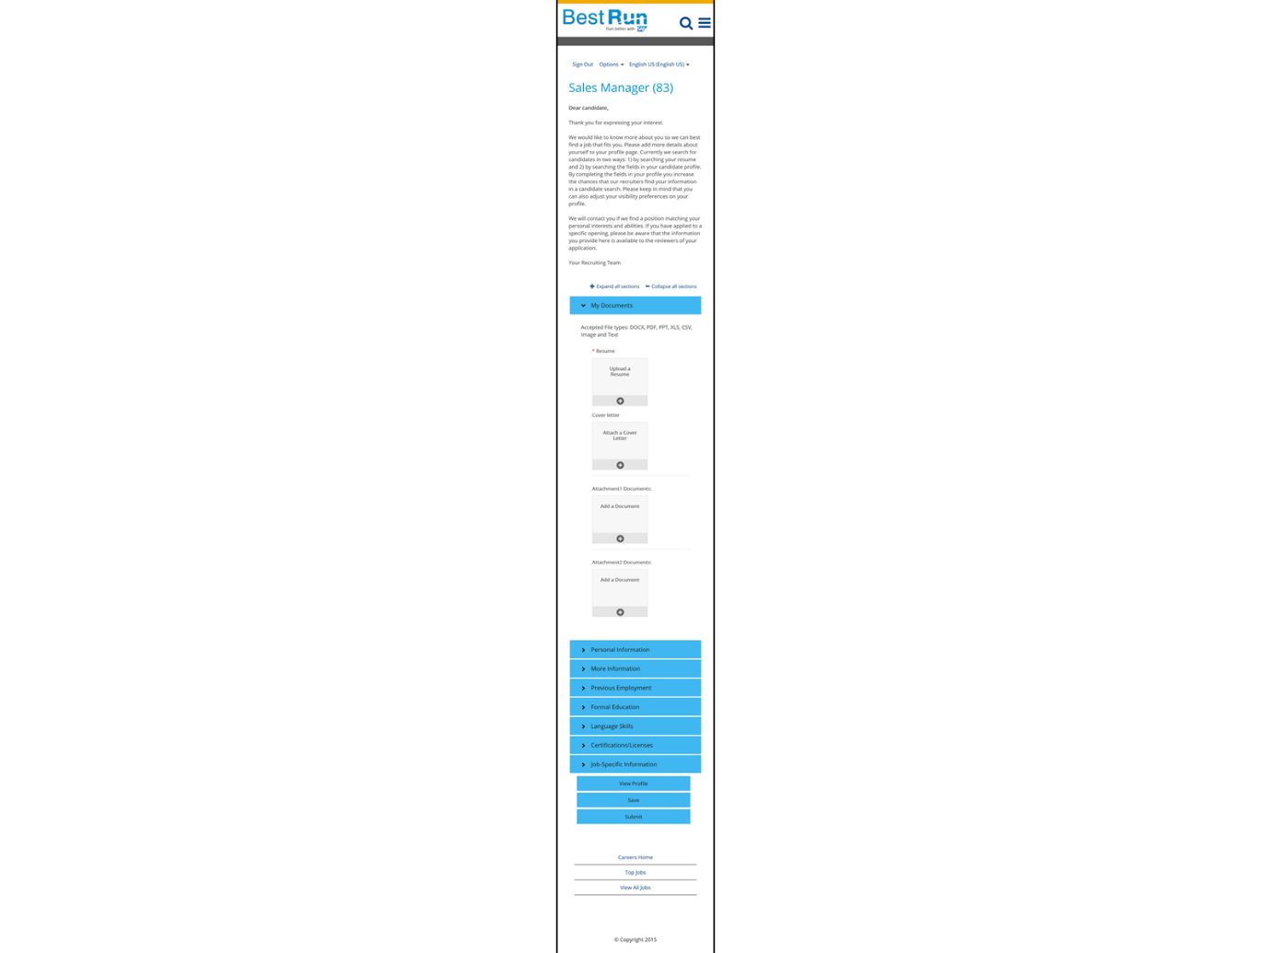
Account Creation
When the candidate chooses Apply Now in the career site, they are directed to the Sign In page.

More information about candidate flow includes the following:
- If the candidate does not already have an account, they complete the Create an Account page. This begins the candidate’s profile in SAP SuccessFactors Recruiting.
- Candidates can create an account without applying for a job.
- Note that additional fields cannot be added to the Create an Account page, nor can fields be reordered. The fields shown within the boxes in the Candidate Flow: Create an Account figure, were added automatically when the Data Privacy Consent Statement was enabled.
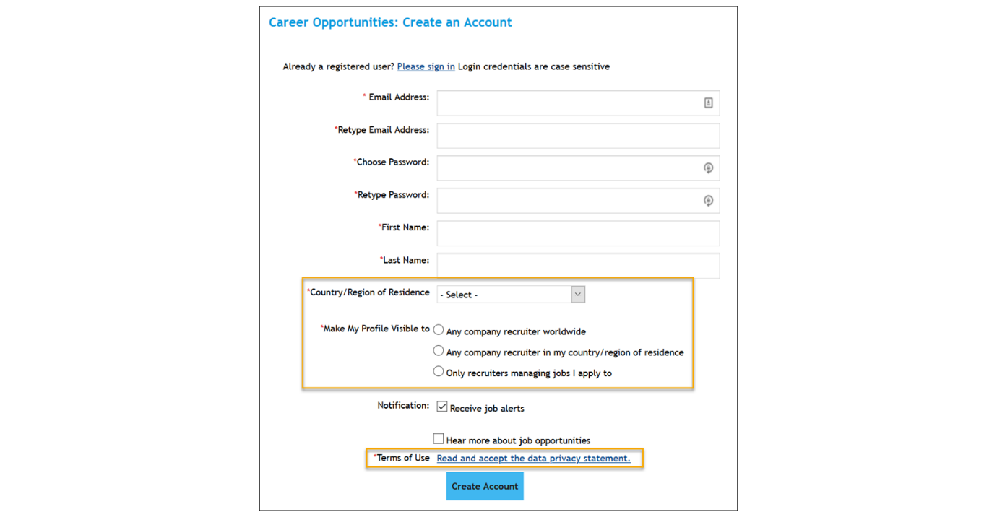
- Creating an account is the same as "joining the Talent Community." They will begin receiving job alert emails.
- Job alerts are added automatically, depending on where the candidate has navigated. For example, if a candidate is on the Engineering jobs page when they apply, they will receive alerts related to that type of position.
Email Verification Options
Customers have options when using email verification:
- Use email verification with a one-time password. This feature is enabled by default if Use email as external applicant user ID option is enabled in Provisioning.
  - When an external candidate creates an account from the career site, an email with a one-time password (OTP) is sent to the provided email address. The candidate must then enter the valid OTP on the Create an Account page to continue with account creation.
  - The feature can be disabled using a switch under Admin Center→Manage Recruiting Settings. The default email content can also be modified.
- Enable email verification functionality with a Recruiting Email Trigger.
  - This option is enabled from Admin Center→Recruiting Email Triggers - Career Site E-Mail Notification.
  - In this case, the candidate is first prompted to verify their email address through a link that they receive through email. However, a one-time password is not provided or required.
  - However, if email verification with a one-time password is enabled, this option is ignored.
Candidate Profile
Choosing View Profile from the Career Site Builder career site opens the candidate profile. Candidates can access Jobs Applied and Saved Applications through the profile.
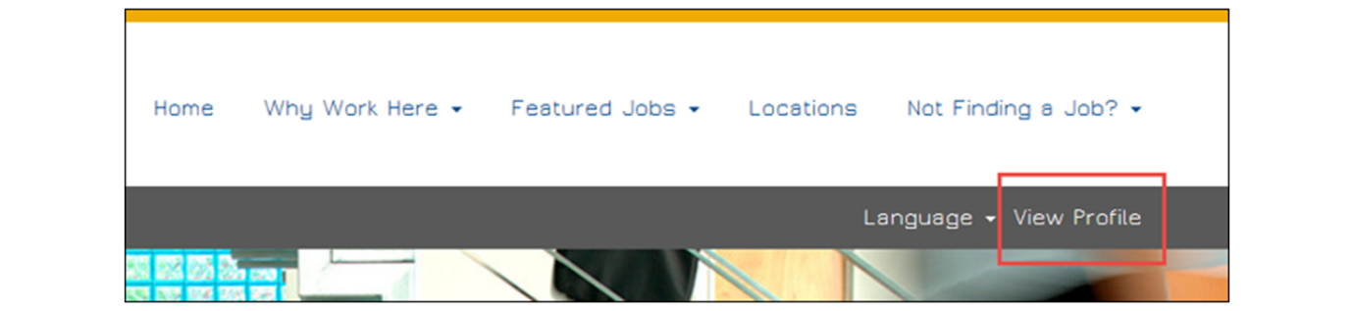
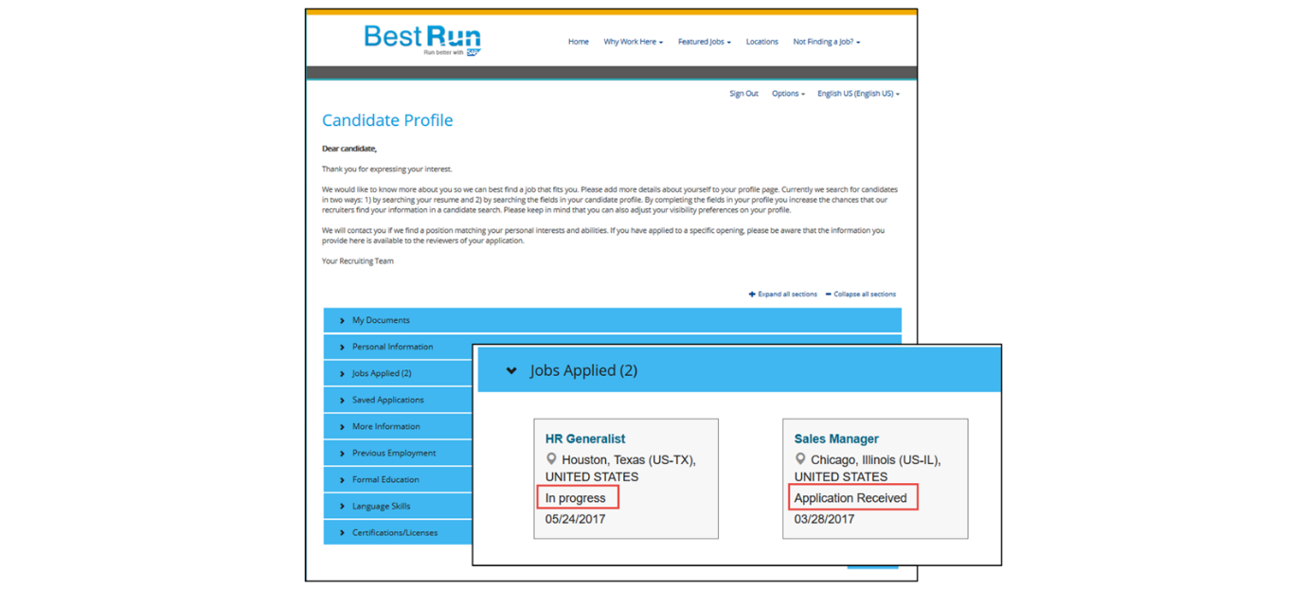
Social Apply
When a candidate selects the Start apply with LinkedIn option, some fields on the candidate profile are automatically completed with information from the candidate’s LinkedIn profile, which makes the application process faster and easier for the candidate.
When LinkedIn is enabled from CSB→Tools→Social Apply, it will not display on the career site until the customer establishes a contract with LinkedIn and additional configuration is completed in SAP SuccessFactors. See the Recruiting guide for more information
If your customer does not take advantage of Apply with LinkedIn, recommend the use of resume parsing so that fields from the uploaded resume populate fields on the profile/application.
Both features can be enabled (and, in fact, the Admin Center mapping is the same), but your customer needs to decide on the candidate experience they wish to provide. For example, if both are enabled, they can make uploading a resume optional for the candidate. But be aware that if a candidate begins their application using Apply with LinkedIn and they upload a resume, then the resume parsing functionality overrides all details provided from the candidate’s LinkedIn profile.


Enable Mobile Apply
This video provides a demonstration of how to enable Mobile Apply.
Business Example
You need to enable and test Mobile Apply.
Task 1: Enable Mobile Apply in Admin Center
Steps
- Log in to your SAP SuccessFactors Human Capital Management (HCM) instance as the admin.
- Navigate to the Admin Center.
- Use the Action search to navigate to Recruiting→Manage Recruiting Sites and ensure that the following fields are enabled:
  - Enable V12 External Career Site
  - Enable Mobile Apply
- The following fields may also be enabled. Select the first two fields: Dropbox and Google Drive.
  - Enable Upload of documents from Dropbox.
  - Enable Upload of documents from Google Drive.
  - Show only Required Fields in Mobile Applications (to keep the list of fields short for mobile users). Do not select this option for class.
Task 2: Test Mobile Apply
Steps
- Open your Best Run site by using Preview or by selecting the quick link in Command Center or the go link next to the Site URL from CSB→Settings→Site Configuration→Site Information.
- Select View Profile to ensure that you’re not already logged in as a user. If you are, click Sign Out.
- Navigate to an open position, from Career Opportunities in the header, for example.
- Select Apply Now.
- Under Not a registered user yet? choose Create an account.
- Complete the Create an Account page: Email Address, Password, First Name, and Last Name. Also select Country, visibility settings, and notification options, and accept the data privacy statement. (Remember that each candidate you create must have a unique email address.)
- SelectCreate an Account.
- You will be directed to a one-page candidate profile/application. If desired, resize your browser window to the approximate dimensions of a mobile device before completing.
- Complete the required fields. Note that uploading a resume is required. The application questions are under the banner Job-Specific information. When complete, choose Apply.
- You will receive the message Your application has been sent. Thank you.
- Select View Profile and notice the information that was saved.
- To confirm that the application was received, log in to SAP SuccessFactors Human Experience Management (HCM) as the recruiter, Paula Price, and navigate to Recruiting.
- From the Job Requisitions page, locate the job and view the Candidate Workbench. Your candidate will appear in the New Applicant (Default) status.
- Move the new candidate to the next status on the Talent Pipeline: Recruiter Review.
welcome to Unit 3,
Completing the Initial Setup of the Recruiting System. In this unit, you'll learn
the essential steps to seamlessly integrate the backend systems of SAP
SuccessFactors Recruiting and Career Site Builder,
known as Provisioning and Command Center,
to ensure a seamless connection between the two modules
to allow for critical synchronizations,
such as job posting data. You'll ensure all necessary system
setup configurations are complete, including enabling
role-based permissions for recruiting users and synchronizing user and job
posting data. You'll discover leading practices,
such as enabling the unified data model in Career Site Builder. This enhances advanced searching
and other capabilities, making it easier for candidates
to find jobs in their various locations. You'll go through the detailed
process of integrating the recruiting backend systems. During this phase, thorough testing
is crucial to ensure a smooth career site configuration. You'll create several test
requisitions in the stage environment to aid
in the implementation process. Let's get started on completing
the initial setup of the Recruiting system.

Now that Maya and Carlos have worked
to finalize the implementation contract with Best Run,
they will now begin work on setting up the customer's back-end systems,
Provisioning and Command Center. Those meetings with Best Run went
really well. What's next up for us to tackle
together? Are we ready to build the site? Not quite. Now comes the unglamorous, yet
essential step. We're going to connect the backend
systems together. Do you remember what those systems
are? I think so. Are they Provisioning and Command
Center? That's right. Do you know why we need to connect
the two systems? I don't. Let's talk about it. These environments must be connected
before configuration of the career site can begin. Think of it this way. The two systems need to be
able to talk to each other. We will ensure that permissions
for the users involved in managing the career site are synced up,
and that jobs created in the Recruiting solution display
on the site. Seems like lots of steps. I'd say it's
about a five-step process. Here's a high-level overview of how
the integration process will go. First, we will enable CSB
and configure the data center links to synchronize the candidate job
and user data between the two systems. Next, we'll configure access to CSB
for Recruiting admins through role-based permissions. After that, we'll
make sure to schedule how often the job posting synchronization
should occur. Then typically,
we would enable the unified data model. I'll come back to this point
in a moment. And of course,
we will troubleshoot at the end. This makes sense. Do you have any examples of what
the end result looks like from past projects
you've worked on? Sure, let's look
at a different environment and talk about the synchronization
of job postings. Our goal is to take the job
requisition data created in the Recruiting module
and send it to Career Site Builder so that the job postings will appear
to candidates. First, the Recruiting Marketing Data
Center URL will provide the base URL, allowing the Recruiting ATS to know
where to send the job posting data needed for Career Site Builder. Next, the API credentials
provide the username and password to allow the systems to fully connect
and talk to each other. Lastly, we need to create a job
in Provisioning to schedule a full job sync from SAP SuccessFactors
Recruiting to Career Site Builder once a day. This is in addition to immediate
syncs whenever a job requisition is created, updated, or deleted. Here's a pop quiz for you, Carlos. What functionality
allows for advanced searching capability so that candidates
can easily find jobs in their various locations
and filter the search results? Easy, it's the unified data model. Nice, the good thing
is that it's already configured in Best Run's Recruiting environment
to enable it in Career Site Builder, it's a simple toggle switch
under Settings, Site Configuration.
Before an integration between
the SAP SuccessFactors Recruiting and Career SiteBuilder environments
can be configured, first, you must enable Career SiteBuilder
in Provisioning. Begin the setup by logging into Provisioning and
navigate to Company Settings. Enable Recruiting Marketing. Select the following switches
Enable Job Marketing, Enable Career SiteBuilder, and Enable
Candidate Account Simplification. Once you have enabled the
appropriate switches, click Save.

Once Career Site Builder is enabled, the integration between the
two systems can begin. First, you need to specify
the Recruiting Marketing Datacenter URLs within Provisioning.
Navigate to Managing Recruiting Configure Recruiting
Marketing Data Center URL. For the first three
fields, enter the URLs provided in the Recruiting
Implementation Guide. Specific URLs are provided for
each RMK data center. You will need to know which data center
your CSB site is hosted on. To complete the last two fields for
the RMK Portal URL, you will need to create your unique Career Site
URL using your system's company ID. Later in the course, you will
also need to insert this URL in Career Site Builder Settings
Site Configuration Site URL. Create your RMK Portal URL
and add it into Provisioning. For training instances,
the site URL should contain the company ID
followed by SAPS DemoJobs. For the last field, RMK Job Search
URL, you can copy the RMK Portal URL and simply add a backslash,
search and save your changes.

In this exercise, you will
update the HR coordinator's email address to an email
address you have access to. Within your instance, navigate
to Manage Users and use the search bar to find and
select the HR coordinator. Change the email address to your own. If desired, you can change the
email address for additional recruiting users using a
Gmail account or a tool such as 33mail.com to create
unique email addresses that are forwarded to a singular
email address you can access.

In this exercise, we
will provide role-based permissions to the admin
and recruiting users to access Career Site Builder
through Admin Center. Navigate to Manage Permission Roles in Admin Center. Select
the Administrator role. Edit the role to add
additional permissions. Within Manage Recruiting, I
select the following permissions. Manage Career Site Builder and set up Recruiting Marketing Job Field Mapping Save your changes Next, you will need to provide
your staffing role assigned to your recruiting users with
the necessary permissions Select Staffing, edit the role
to add additional permissions Within Recruiting Permissions,
provide the Recruiting RM, KSSO Permission and the
Job Marketing Permission. Save your changes.

In this exercise, we will
enable MobileApply to create a responsive design for
the career site. Use the action search to navigate
to Manage Recruiting Sites. Ensure that the following
fields are enabled. Enable V12 External
Career Site, then enable Mobile Apply. The following
fields may also be enabled. Enable Upload of Documents
from Dropbox. Enable Upload of Documents from Google Drive. The
last field, show only required fields in mobile applications,
keeps the list of fields short for mobile users. In training,
we will not enable this setting.

Configuring Access to Career Site Builder for Recruiting Administrators
Objectives
After completing this lesson, you will be able to:
- Create a unique security key using a secure password generator.
- Configure site integrations in Career Site Builder.
Configuring Access to Career Site Builder for Recruiting Administrators
When building the integration between the SAP SuccessFactors Recruiting module and Career Site Builder (CSB), two main synchronization jobs will need to be configured: Recruiter Sync and Real Time Job Sync. During the initial set up in Provisioning, the data center URLs were configured to allow the system to understand where to send data. During these next configuration steps, you will create the credentials needed for the synchronization of recruiter user data and permissions to be sent, specify the instance details, as well as when the recruiting user synchronization job should be scheduled.
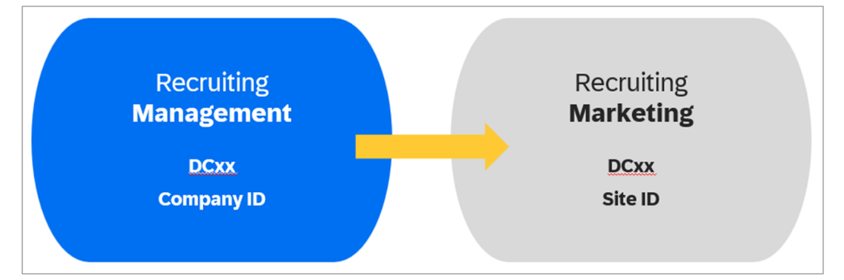
Recruiter Single Sign On (Recruiter SSO)
Recruiter Single Sign On is a prerequisite for accessing Career Site Builder from Admin Center and required for any user who needs to access Recruiting Advanced Analytics.
Note that each user must have a unique email address; this is only an issue for training. The email addresses used for testing do not have to be valid email addresses.
Note
When setting up Recruiter SSO, be sure to reference the data center where the customer’s SAP SuccessFactors instance is hosted.
Confirm Company Settings in Provisioning
To ensure Recruiter SSO is enabled, confirm the following company settings are enabled in Provisioning as follows:
Steps
- Log in to Provisioning and navigate to Company Settings.
- Confirm the following settings:
  - Use email as external applicant user ID
  - Disable CAPTCHA on the External Career Site for Account Creation
Security Key
Next, you need to generate a unique password for Provisioning and Career Site Builder to use when synchronizing recruiting user data. This password is known as the security key. To generate the security key, it is recommended to use a password generator to ensure it is unique and secure.
Requirements for the Security Key
Use a secure password generator with the following parameters:
- From 20-28 characters
- At least one upper and one lower case letter
- At least one numeric character
- At least one special character/punctuation
The security key must be unique across all Career Site Builder sites in a data center.
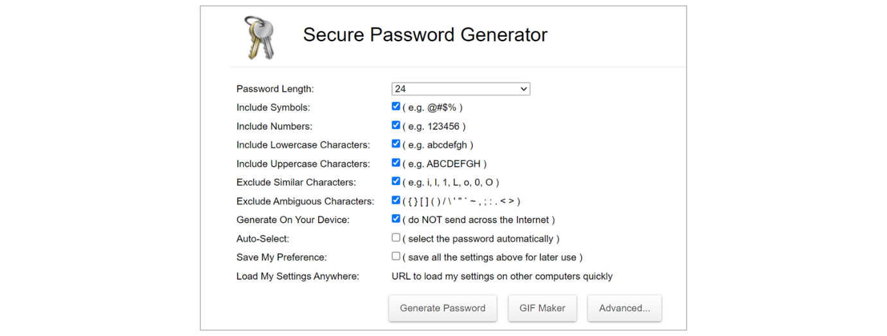
Site Integrations Configuration
Next, you must then configure the Site Integrations, which hosts the security key as well as the SAP SuccessFactors Recruiting tenant details to create the integration that allows the recruiting user data synchronization. For a new customer, Site Integrations will be empty. Then, populate to match the settings in Provisioning.
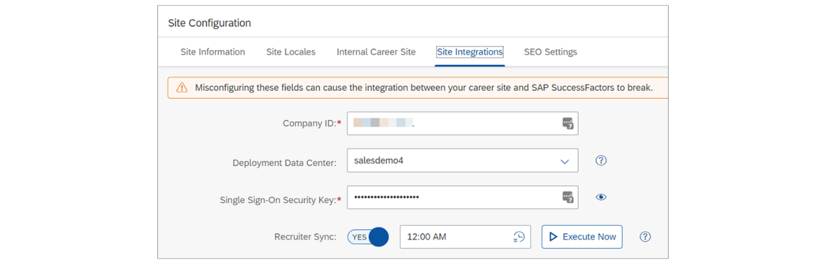
Within CSB, navigate to Settings→Site Configuration→Site Integrations.
- Company ID: Copy from Provisioning. In the training instances, ensure that the Company ID is entered in all Capital letters (ALL CAPS).
- Deployment Data Center: Select the data center where SAP SuccessFactors HCM is hosted.
- Single Sign-On Security Key. Review the requirements in the section titled Security Key.
Run Recruiter Sync
To run Recruiter Sync, proceed as follows:
Steps
- In Recruiter Sync, select Yes.
  - To save, you must first enter a time to sync each day. Leading practice: Enter a time after the user data file is loaded, outside of the customer’s normal business hours, such as 12:00 AM.
- Choose Save.
- To run Recruiter Sync, choose Execute Now.
- After a few minutes, check that users have synced from Users→Roles→Admin Users.
- Select Refresh icon.
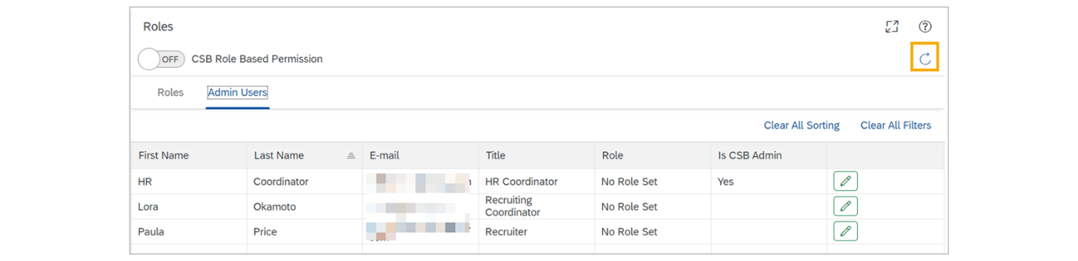
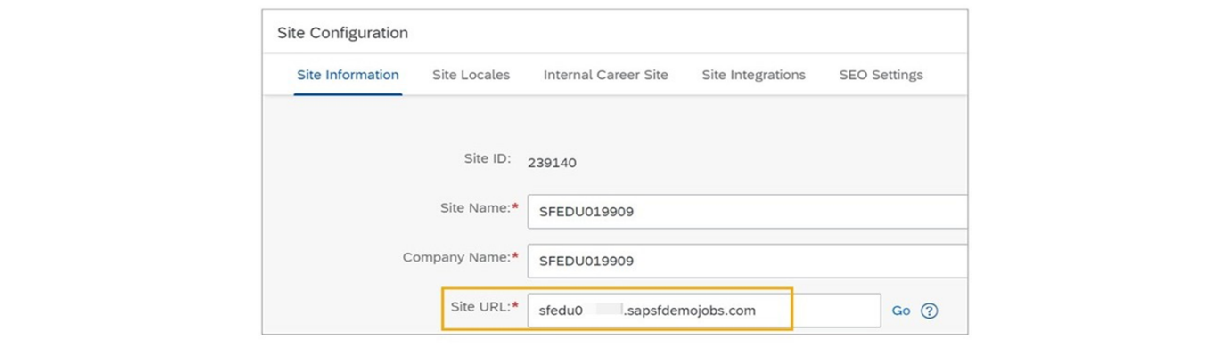
Troubleshoot Recruiter Sync
To troubleshoot Recruiter Sync, proceed as follows:
Steps
- From Command Center→Site Details page, choose Export Automated Process Logs.
- Select a Date Range for the logs, up to two days.
  - The bulk of the log data is generated during nightly maintenance runs, but could also result from manual maintenance requests performed by Command Center users. The log includes details for both Recruiter Sync and Real Time Job Sync.
- Check for errors related to the Recruiter sync job.
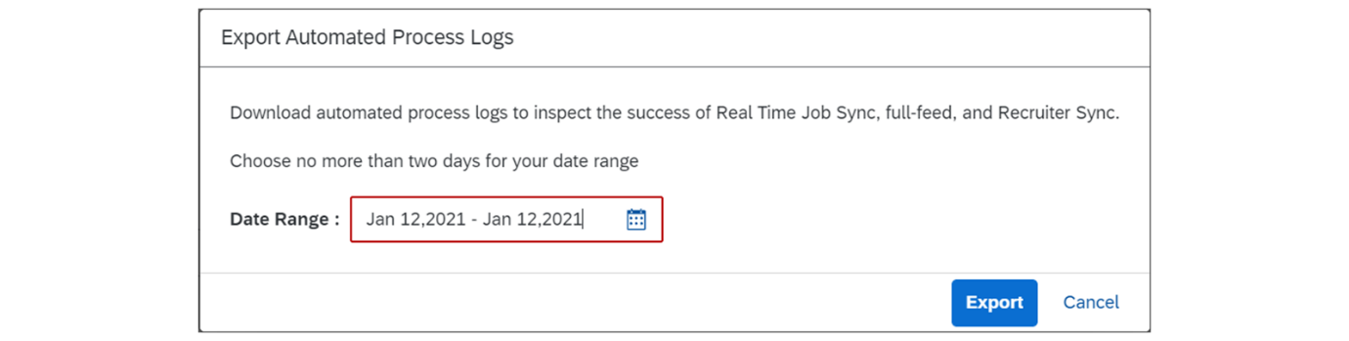
Configure Security Key for Site Integration
This video provides a demonstration of configuring the security key for a site integration in Career Site Builder.
Business Example
Continue the site setup by configuring the site integrations.
Steps
- Access Career Site Builder by using the quick link in Command Center.
- Navigate to CSB→Settings→Site Configuration→Site Integrations and complete following information:
  - Company ID. You can copy this information from email that you have before class, from Provisioning or from Site List Page in Recruiting Command Center.
  - Deployment Data Center. You can find this information in Site List Page in Recruiting Command Center.
  - Single Sign-On Security Key: Use a secure password generator with these parameters:
    - 20 to 28 characters long
    - At least one upper and one lower case letter
    - At least one numeric character
    - At least one special character/punctuation
  - Enable Recruiter Sync.
  - Set time to 12:00 AM.
  - Select Save.
Enable Recruiter Single Sign On
This video provides a demonstration of enabling recruiter single sign on.
Business Example
Enable and test Recruiter SSO to enable users to access Career Site Builder from Admin Center.
Task 1: Confirm Company Settings in Provisioning
Steps
- Log in to Provisioning.
- Navigate to Company Settings→Recruiting.
- Enable the following settings:
  - Use email as external applicant user ID.
  - Disable CAPTCHA on the External Career Site for Account Creation.
- Select Save.
Task 2: Test Recruiter Sync
Steps
- While still at CSB→Settings→Site Configuration→Site Integrations, proceed as follows:
  - Select Execute Now.
  - Navigate to CSB→Users→Roles→Admin Users, and select the refresh icon to confirm that the users were synced over and are available in the list of the admin users. If user were not synced over, wait a few minutes and then select refresh icon again. These will be the users with these role-based permissions: Manage Career Site Builder and Recruiter SSO (admins and Staffing). Later we will assign roles within Career Site Builder to these users.
Note
If all the Staffing Department and the admin did not sync over, check that each of them has a unique email address. See additional troubleshooting tips at the end of this unit.
Task 3: Test Manage Career Site Builder
Steps
- If users with the required permissions do not sync, navigate to Command Center→Site Details page.
- Click Export Automated Process Logs.
- Enter today's date and click Enter.
- Download the .zip file and extract the .txt file from it.
- If your issue is not resolved, see additional troubleshooting suggestions at the end of this unit.
Note
The most common error while working in training or testing environment is that users do not have unique email addresses.
Note
Since the information is being synced between Command Center and Admin Center in Recruiting, there will be a delay before users can access Admin Center→Manage Career Site Builder. See the troubleshooting suggestions for more information.
Task 4: Update the Site URL in Career Site Builder
Now that all of the required fields have been completed for the CSB→Settings→Site Configuration pages, we are able to update the Site URL for instances.
Steps
- Return to the Site Information page from CSB→Settings→Site Configuration, and add the domain name .sapsfdemojobs.com at the end of the Site URL. For example, sfedu0XXXXX.sapsfdemojobs.com.
- Select Save.
- Select go to open your Career Site Builder site. A new tab opens, displaying a page with a gray background.
Create the security key for the
RecruiterSync you will need to access Career SiteBuilder by using
the quick link in Command Center. Navigate to CSB, Settings,
Site Configuration then Site Integrations and complete
following information. Company ID Deployment Data Center And finally, the single sign on
security key. Use a secure password generator using the following parameters,
20 to 28 characters long. At least one upper and one lower case letter.
At least one numeric character. At least one special character
punctuation. When you have created your password, insert the
password into the security key field. Enable Recruiter Sync.
Set time to 12am. Select Save.

First, log into Provisioning. Navigate to Company Settings Recruiting. Enable the following settings. Use email as external applicant user ID. Disable capture on the
external career site for account creation. This
is for training purposes, so we can quickly create
new candidate accounts. Select Save. Within Career Site Builder,
navigate to Settings, Site Configuration, Site Integrations,
then proceed as follows. select execute now then
navigate to CSB users roles then click on admin users and
select the refresh icon to confirm that the users were
synced over and are available in the list of the admin users
if users were not synced over wait a few minutes and then
select the refresh icon again.

Configuring a Scheduled Job to Sync Active Jobs to the Career Site
Objectives
After completing this lesson, you will be able to:
- Configure data mapping from the job requisition to SAP SuccessFactors Recruiting Marketing.
- Configure API credentials in Career Site Builder.
- Configure service provider settings in Provisioning.
- Configure a daily job sync from Recruiting to Career Site Builder.
Job Requisition Data Mapping
The next large synchronization that needs to be configured is the Real Time Job Sync. Before configuring this integration job, you first need to complete the job requisition data mapping, which identifies which fields in the job requisition should be used for Career Site Builder (if the Unified Data Model is not enabled), Recruiting Advanced Analytics, and XML feeds.
The following should be considered when completing the data mapping:
- System requirements: Career Site Builder accepts a total of 19 standard fields (for example: city, state, zip code) that can be mapped from the job requisition, along with 5 custom fields that can be used as required. This field mapping controls which fields can be used from the job requisition in Career Site Builder features such as job page layouts (job posting pages), search filters, and category page rules.
- Limitations: The customer will most likely have more than 24 fields in their job requisition template, therefore, you may need to be strategic in the field mapping approach.
- Leading practices: To ensure your customer’s configuration is set up successfully, use leading practices for configuring the job requisition data mapping and recommendations.
- Unified Data Model: When the Unified Data Model is enabled, the field mapping for job postings, search filters, and category pages is not required. However, the field mapping is still required for Advanced Analytics and XML feeds.
Unified Data Model | Universal | Without Unified Data Model
- When the Unified Data Model is enabled, the data mapping is not required for CSB features such as job postings, search experience, and category page filters.  - All fields can be used from the job requisition without relying on any field mapping.  - Location data is stored within the Job Location Generic Object (which includes critical information for CSB including latitude/longitude coordinates for the Google Maps component). | - Regardless of whether or not the Unified Data Model is enabled, the data mapping must be configured to support filtering in Advanced Analytics reports as well as XML feeds.  - Customers with multiple requisition templates should use the same mapping where possible.  - Use the information from the Recruiting Data Mapping tab in the Recruiting Marketing workbook. | - If the Unified Data Model is not enabled, the data mapping must be completed for every job requisition template so that the fields are available for use in Career Site Builder.  - When mapping, use the standard fields whenever possible. In other words, do not map to one of the five custom fields if an appropriate standard field is available.  - Custom fields on the job requisition can be mapped, as long as they have a data type of text or picklist on the job requisition. (Once in CSB, the data type doesn’t matter).
Mapping Recommendations
This example assumes that your customer has enabled the Unified Data Model or is using the Location Foundation Object, so all location fields are mapped to Location.
Mapping is completed from Admin Center→Setup Recruiting Marketing Job Field Mapping.
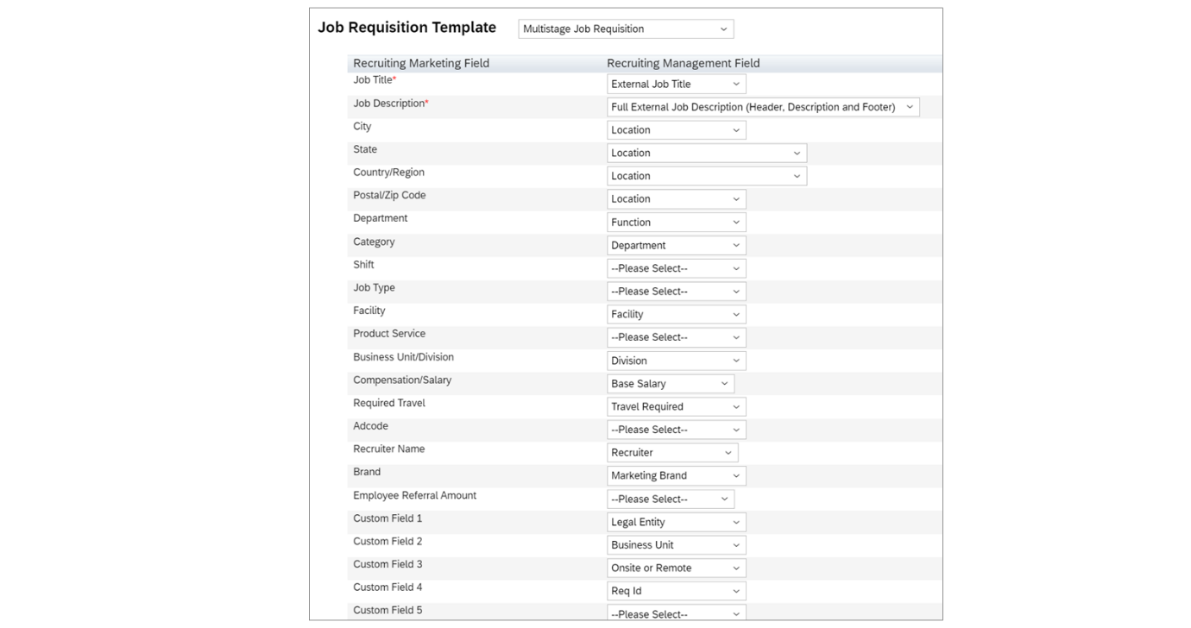
General Mapping Tips
Refer to the following tables in the Recruiting Guide on the SAP Help Portal for specific instructions:
- Field Specifications (under the heading, Data Recommendations for Recruiting Management)
- Technical specifications for Recruiting Marketing fields (under the heading, Career Site Builder Job Data Fields.)
- Mapping Recruiting Marketing Fields to Recruiting Management Fields for Real Time Job Sync (under the heading, Configuring Real Time Job Sync).
Leading Practices for Mapping Department and Dept Fields
The department field is most important for primary categorization, such as for category page rules and search results. The use of a secondary department field, field ID="dept", is another leading practice. Many customers may use this field as "Function" that is used for job classification, often for job boards.
- Both fields (department and dept) need to be on the job requisition template, though they do not need to be visible to all users and may be populated by Position Management or recruiting business rules.
- Sometimes both fields are populated with the same values.
For our use case, we will populate the department field with the name of Best Run’s actual departments, though the names may be modified to be easily understood by external candidates. Remember to make it easy for candidates to search for jobs. We will populate the dept field with the job function (function picklist), to be used primarily for job distribution.
Note that Category in CSB needs to be populated with the data from the job requisition Department field, and Department in CSB needs the data from the Function field.
Remember that how you configure the job data is dependent upon your customer’s needs.
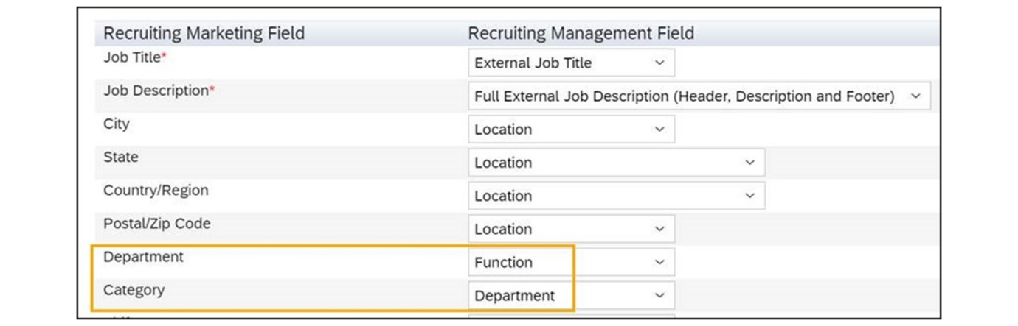
Real Time Job Sync (RTJS)
The Real Time Job Sync is the second integration synchronization job required to complete the integration between the SAP SuccessFactors Recruiting Applicant Tracking System (ATS) and Career Site Builder (CSB). This job is intended to synchronize the job requisition data for jobs posted to the career sites, allowing the job postings to be advertised in Career Site Builder.
Jobs posted externally (from "Corporate Posting" on the Job Postings page) are sent to the CareerSite Builder site in near-real time. Usually, this process happens in under a minute, but depending on the time of day, it can take up to 20 minutes for a job to post in the SAP SuccessFactors ATS career site before it is sent to the CSB career site. SAP SuccessFactors Recruiting also sends job detail updates and job deletes to the CSB career site.
While Career Site Builder is intended to be integrated with the SAP SuccessFactors Recruiting ATS, other applicant tracking systems can also be integrated with Career Site Builder. However, the Real Time Job Sync is only available for SAP SuccessFactors Recruiting customers, not those using a different applicant tracking system.
- Real Time Job Sync is pre-set from CBS→Settings→Site Configuration→Site Information and cannot be disabled.
- Existing customers must run a full feed at go-live in order to sync their existing posted jobs. A full feed is a complete listing of all of a client’s existing posted jobs, and it provides a baseline that allows the job sync to add or remove jobs as appropriate.
- To run a full-feed of all currently posted jobs from the SAP SuccessFactors ATS site to the Career Site Builder site in regular intervals, you must define the sync using the Job Scheduler in Provisioning. Before configuring a full feed, you must complete the Real Time Job Sync field mapping.
Configure API Credentials in Career Site Builder
To configure API credentials in CSB, proceed as follows:
Steps
- Navigate to CSB→Tools→Manage API Credentials.
- Choose Add New Provider.
- Complete the following:
  - Provider ID: Auto-generated
  - Provider Name: Enter the Folder Name from the Command Center Site Details page, then a dash, then the Site ID from the same page. Use this format: Folder Name-Site ID
  - Password: System-generated
  - Username: The same as Provider Name (Folder Name-Site ID)
  - Recruiting Management (Real Time Job Sync): Yes
- Save.
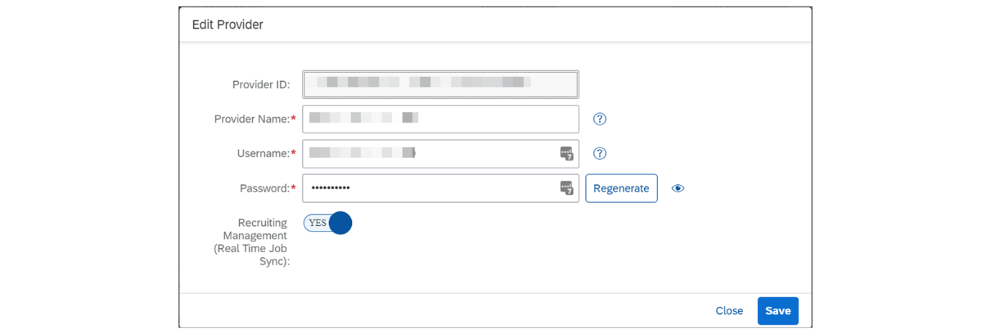
Note
If you later need to connect an existing Career Site Builder instance to a different SAP SuccessFactors HCM instance, you will need to replace the API credentials.
Configure Service Provider Settings in Provisioning
To set up Service Provider Settings in Provisioning, proceed as follows:
Steps
- Navigate to Provisioning→Service Provider Settings→Recruiting Marketing Settings.
- Complete the following:
  - Security Key: Copy from CSB→Settings→Site Configuration→Site Integrations.
  - Copy the other settings from CSB→Tools→Manage API Credentials.
  - API Key for Job Post Sync: (Provider ID)
  - User name for Job Post Sync: (Username)
  - Password for Job Post Sync: (Password)
  - Expires in (seconds): 360
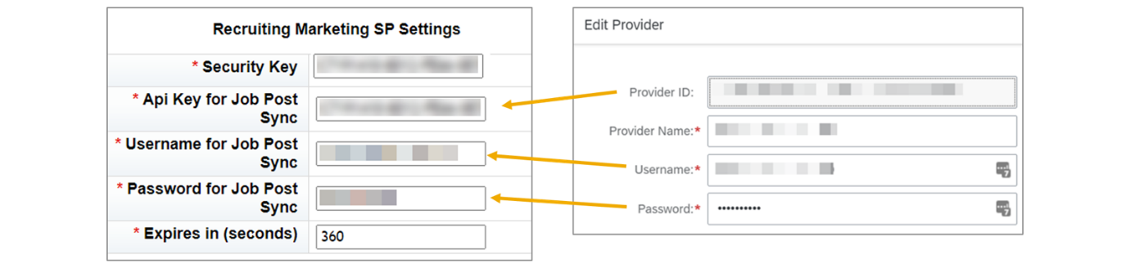
Configure Daily Job Sync to Career Site Builder
In addition to the Real Time Job Sync, you can set up the job scheduler in Provisioning to run a full-feed of all posted jobs from the SAP SuccessFactors ATS site to the Career Site Builder site on a daily basis.
To set up daily job sync to Career Site Builder, proceed as follows:
Steps
- Navigate to Provisioning→Managing Job Scheduler→Manage Scheduled Jobs.
- Create a new job and select Sync all external job postings for the Job Type.
- Set up the job to recur daily, at off-hours for the customer’s business.
- Submit and select Run It Now.
Real Time Job Sync Testing
You can test that the jobs were synced to the career site even if you have not yet begun building pages. Add /search to the site URL from Command Center or Career Site Builder.
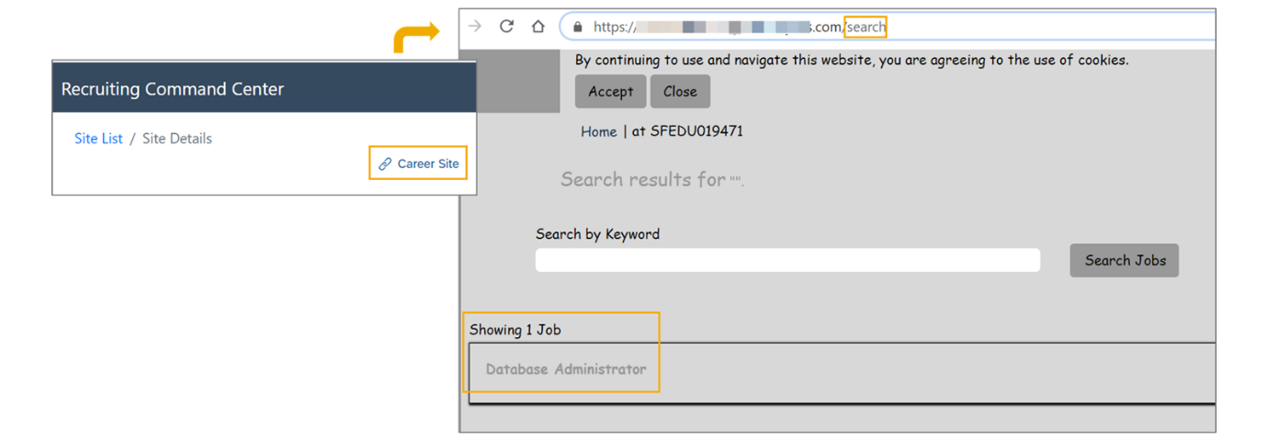
Troubleshoot Real Time Job Sync
To troubleshoot Real Time Job Sync, proceed as follows:
Steps
- To verify the success of the job sync and to troubleshoot any errors, navigate to Command Center, and choose Export Automated Process Logs .

- Select Export Jobs to CSV to export all jobs in a CSV file. Specify what types of jobs to export, such as internal or external jobs, active or inactive, and so on, to further troubleshoot.
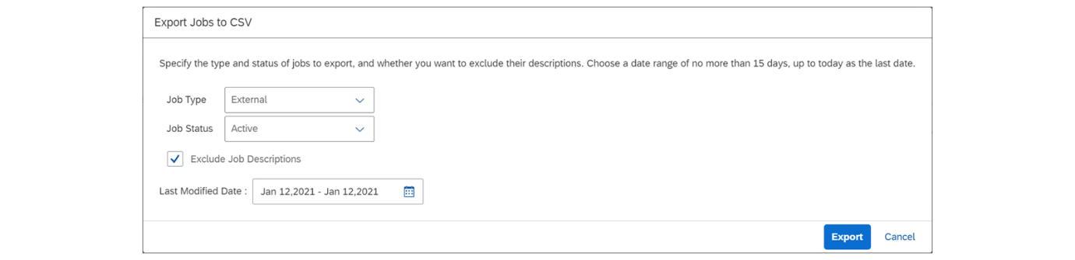
Enable Real Time Job Sync
This video provides a demonstration of how to enable Real Time Job Sync (RTJS).
Business Example
In this exercise, you configure Real Time Job Sync (RTJS) in your training instance. You also use the Job Scheduler in Provisioning to set up a daily backup of jobs to the career site.
Task 1: Configure API Credentials in Career Site Builder
Steps
- Navigate to CSB→Tools→Manage API Credentials.
- Choose Add New Provider User and complete the fields with the following information:
  - Provider ID field will be already completed. This is a system-generated ID.
  - Provider Name field. Enter the Foldern Name from the Command Center Site Details page, then a dash, then the Site ID from the Command Center→ Select Site Name. On Command Center Site List page locate Folder Name and copy the details.
Alternatively you can get the information from CSB→Settings→Site Configuration→Site Information). Use this format: Folder Name- Site ID e.g. sfedu123456-123456
  - User name field. This will be the same as Provider Name (Folder Name-Site ID).
  - Password field. This is a system-generated ID and information will be already available.
  - Recruiting Management (Real Time Job Sync) field. Select Yes
  - Choose Save.
Task 2: Set up Service Provider Settings in Provisioning
Steps
- Use the same values you entered in Career Site Builder. Log in to Provisioning and navigate to Service Provider Settings→Recruiting Marketing Settings and enter the following information:
  - Security Key: Copy from CSB→Settings→Site Configuration→Site Integrations. Note that you'll need to select Select (eye icon) next to Single Sign-On Security Key to view the key before it can be copied successfully. After these settings are saved, this key is stored in the system, but disappears from the Provisioning UI, so later if you need to make changes to additional fields here, you must re-enter the security key.
  - API Key for Job Post Sync: Enter the Provider ID from the CSB→Tools→Manage API Credentials.
  - Username for Job Post Sync: Enter the Username from CSB→Tools→Manage API Credentials.
  - Password for Job Post Sync: Enter the Password from CSB→Tools→Manage API Credentials.
  - Expires in (seconds): The suggested setting is 360.
  - Choose Save.
Task 3: Map the Job Requisition Fields to Career Site Builder
Steps
- Log in to your SAP SuccessFactors Human Capital Management (HCM) instance as the admin.
- Navigate to Admin Center→Setup Recruiting Marketing Job Field Mapping.
- Select the Job Requisition template. In our training instance, it is the Corporate Job Requisition.
- Map the fields as shown below.
Note
You will not be able to map the Brand field yet.
Mapping Job Requisition Fields to Career Site Builder
Recruiting Marketing Field | Recruiting Management Field
Job Title* | External Job Title
Job Description* | Full External Job Description (Header, Description, and Footer)
City | Location
State | Location
Country/Region | Location
Postal/ZipCode | Location
Departing | Fuction
Category | Department
Shift | Select from dropdown list
Job Type | Select from dropdown list
Facility | Facility
Product Service | Select from dropdown list
Business Unit/Division | Division
Compensation/Salary | Base Salary
Required Travel | Travel Required
Adcode | Select from dropdown list
Recruiter Name | Recruiter
Brand | Select from dropdown list.  Note  Later you will map to Marketing Brand.
Employee Referral Amount | Select from dropdown list
Custom Field 1 | Legal Entity
Custom Field 2 | Business Unit
Custom Field 3 | Onsite or Remote
Custom Field 4 | Req Id
Custom Field 5 | Select from dropdown list
- Choose Save.
Task 4: Set up Daily Job Sync to Career Site Builder
Use the Job Scheduler in Provisioning to sync your existing posted jobs to the career site. Run the job now, and set it up to run nightly.
Steps
- Log in to Provisioning and navigate to Managing Job Scheduler→Manage Scheduled Jobs.
- Choose Create New Job and enter the following information:
  - Job Name:Sync Recruiting Jobs.
  - Job Owner: Click Find User and search for and select the admin user (HR Coordinator).
  - Job Type: Select Sync all external job postings
  - Occurrence: Recurring.
  - Recurring Pattern: Select Daily and 0 (12AM).
  - Start Date: Enter today’s date (using this format: MM/DD/YYYY), and 10 minutes after the current server time that is shown.
  - End Date: Leave blank. No additional fields need to be completed.
  - Click Create Job.
  - From the Select dropdown list, select Submit.
  - From the same dropdown list, select Run It Now.
Note
From the Manage Scheduled Job page, you can click Monitor Jobs to view the status of scheduled jobs. Search the page for the Sync Recruiting Jobs job, and ensure that the Status is Completed. See troubleshooting information at end of this unit.
Task 5: Test Real Time Job Sync
From Career Site Builder, check that you are able to view the view the jobs you created.
Steps
- From CSB→Settings→Site Configuration→Site Information, click Go next to the Site URL.
- Insert /search to the end of the URL (for example, https://sfeduXXXXX.sapsfdemojobs.com/search) and click Enter.
- View the externally posted job requisitions that are displayed.
Note
There will be a significant delay to view the first jobs that are synced to Career Site Builder. Be aware that jobs that can be filled in multiple locations will not sync until the Unified Data Model is enabled.
- Refresh the search page until you can confirm that all of your jobs display in the career site.
Task 6: Troubleshoot Real Time Job Sync
Steps
- If after a few hours, your externally posted jobs do not sync, navigate to Command Center→Site Details page.
- Choose Export Automated Process Logs.
- Enter today’s date and click Enter.
- Download the .zip file and extract the .txt file from it. View the Import Jobs - ATS fullfeed job at the top. If the jobs are not yet displaying on the CSB site, check that the correct number of jobs is reflected on the <jobs-queued> line.
- To further troubleshoot, from Command Center, select Export Jobs to CSV to export all jobs in a CSV file. Specify what types of jobs to export, such as internal or external jobs, active or inactive, and so on.
- If your issue is not resolved, see additional troubleshooting suggestions at the end of this unit.
From Command Center, access Manage
Career Site Builder for your site, navigate to CSB Tools, manage API
credentials, choose a new provider to create a new integration with
SAP SuccessFactors Recruiting. The Provider ID field will be
already completed. This is a system -generated ID. For the Provider Name
field, enter the folder name or company ID, which can be found on
the Command Center site details page. Copy the folder name and
paste it to the Provider Name field. Then add a dash.
Then insert the site ID. The site ID can be found
on the same site details page that you found the
folder name in Command Center. The username field should be
the same as Provider Name. The password field is
a system-generated ID and information will
be already available. For the Recruiting Management, Real
-Time Job Sync field, select Yes. Choose Save. Next, these API credentials
must be added to Provisioning to allow the
systems to fully integrate. Log into Provisioning and
navigate to Service Provider Settings and select
Recruiting Marketing Settings. Enter the following information. Security Key. Copy this
from CSB, Settings, Site Configuration, Site Integrations. Note that you'll need to select
the eye icon next to the Security Key field to view the key before
it can be copied successfully. Next, the API Key for Job
Posting. Enter the Provider ID from the CSB, Tools,
Manage API Credentials, Username for JobPostSync. Enter the username from CSB Manage API Credentials. Password for JobPostSync. Enter the password from CSB Manage API Credentials. Expires in seconds, the
suggested setting is 360. Choose Save. Next, you will need to configure
the job requisition fields to Career Site Builder. This field
mapping is critical for Career Site Builder features such as
XML feeds and advanced analytics. Log into your instance as
the admin user. Navigate to Setup Recruiting
Marketing Job Field Mapping. Select the Corporate Job
Requisition Template. Map the fields as shown in the exercise. Choose Save when you have completed
the field mapping for all fields. Lastly, you will create
the real-time job sync in Provisioning using
the Job Scheduler tool. Log into provisioning and navigate
to Managing Job Scheduler – Managed Scheduled Jobs. Choose
Create New Job and enter the following information. The job name
should be Sync Recruiting Jobs. For job owner, click
Find User and Search for and select the Admin
User, HR Coordinator. For job type, select Sync All External
Job Postings. The occurrence should be a recurring pattern,
set to daily and at 12am. Use today's date as the start
date and set the time to be 10 minutes after the current
server time that is shown. Leave the end date as blank.
no additional fields need to be completed. Click Create Job Now
from the list of jobs. Find the job you have created. A drop-down
menu on the right will allow you to submit and run the job. Now
select Submit then select Run. Now that the real-time job
sync has been configured and ran, you can test your
career site to see if your job requisitions appears
when you search for jobs.

Enabling the Unified Data Model
Objective
After completing this lesson, you will be able to enable the Unified Data Model.
Unified Data Model
Customers are encouraged to enable the Unified Data Model to take advantage of an upgraded search experience, improved support for non-English languages, and more.
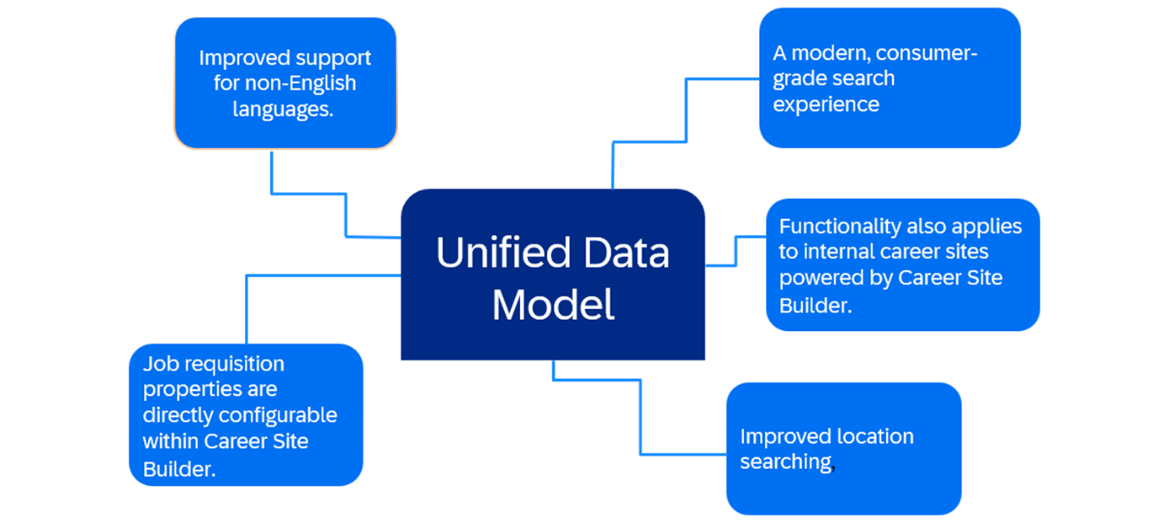
If the Unified Data Model has been enabled in your customer’s environment, this enablement includes configuring the Marketing Brand Generic Object and Job Location Generic Objects and running the ReBuild Job Requisition Search Index job in Scheduled Job Manager.
For existing customers, you will also need to run jobs to convert existing location data and create job locations and brands. After verifying the successful completion of the migration processes by viewing the UnifyConfiguration MDF Object, you can enable the Unify Data Model in Career Site Builder.
From CSB→Settings→Site Configuration→Site Information, select YES for Use Unified Data Model.

Enable Unified Data Model
This video provides a demonstration of how to enable the Unified Data Model.
Business Example
After the setup steps for configuring the Unified Data Model have been completed and verified in Admin Center, and the site setup steps are done, you can enable the Unified Data Model in Career Site Builder.
Steps
- Navigate to CSB→Settings→Site Configuration→Site Information.
- Select YES for Use Unified Data Model.
- Save.
After the setup steps for configuring
the unified data model have been completed and verified in Admin
Center and the site setup steps are done, you can enable the unified
data model in Career Site Builder. Navigate to CSB Settings Site
Configuration Site Information. Select Yes for Use Unified Data Model. Save.

Troubleshooting Setup Issues
Objective
After completing this lesson, you will be able to diagnose and correct system setup errors.
Command Center Logs
Two types of logs are generated from Command Center:
- Export Jobs to CSV – Allows you to export all jobs in a CSV-format file. This report assists in troubleshooting any issues with jobs appearing on the Career Site Builder (CSB) site. Notice in the figure below, it’s clear that values aren’t appearing in the Business Unit/Division field for some jobs, because they weren’t populated on the job requisition.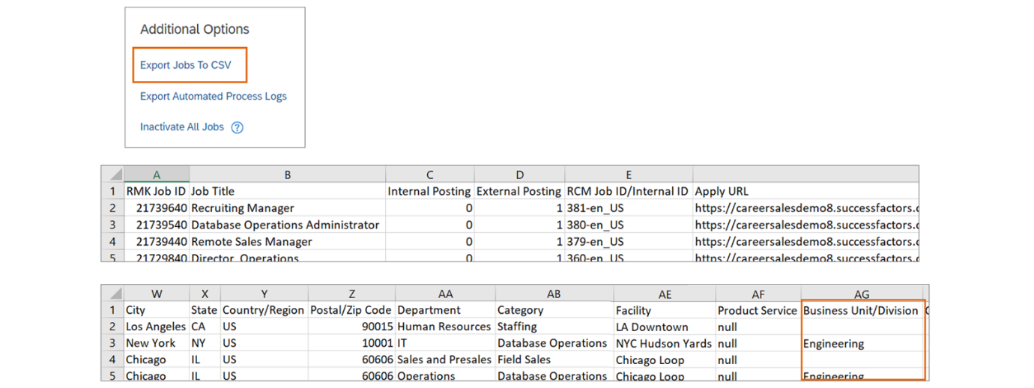
- Export Automated Process Logs – Automated process logs allow you to verify the success of Real Time Job Sync and Recruiter Sync. The figure titled Log: Export Automated Process Logs, demonstrates part of the logging for Real Time Sync Job. Notice that no jobs needed to be updated for this sync.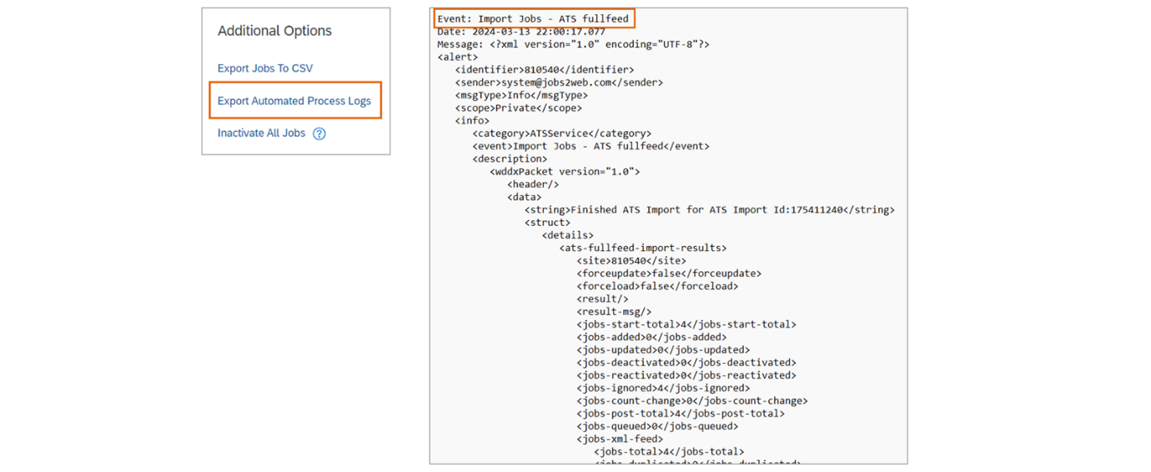
The bulk of the log data is generated during nightly maintenance runs but could also result from manual maintenance requests performed by Command Center users.
Troubleshooting Tips
While completing the initial setup of the Recruiting system, test after each step of the configuration to ensure that the setup was successful. You will not be able to begin configuring the customer’s career site in CSB until everything is working correctly. Refer to the following troubleshooting tips if necessary.
Recruiter Sync Troubleshooting
I cannot see any recruiting users inCSB→Users→Roles→Admin Users.
- Ensure that your Staffing Group is populated from Admin Center→Manage Permission Groups.
- If the recruiters do not appear in Career Site Builder under Users→Roles→Admin Users, check that each has a unique email address. (This is the most common error.)
- After setting up Recruiter Single Sign On (Recruiter SSO), be aware that there will be a delay before a synced user can access CSB via Admin Center→Manage Career Site Builder. Wait for some time to pass, up to a few hours. Try again with an incognito browser.
I cannot access Manage Career Site Builder as a recruiting user.
- If Manage Career Site Builder is not an option for that user from Admin Center: Check Role-based Permissions for the user. If that permission is not available, go to Provisioning, select Company Settings, and refresh RBP Permission Configuration.
- If you are being redirected back to the SAP SuccessFactors home page: This can occur when the user is not set up for Recruiter SSO or the security key is not configured correctly. It may also be experienced during the blackout period, between the Preview and Production releases. The CSB instance is on a stage environment, therefore on the latest version; while the SAP SuccessFactors HCM instance is on a productive environment, which means it's still on the previous version.
- If you are being redirected to www.sap.com: This is an indication that the URL of the career site does not exist. To check, go to CSB, select Settings→Site Configuration→Site Information: Site URL. For other redirect issues, also check the Recruiting Marketing Data Center URLs.
I receive an error when trying to access Manage Career Site Builder.
- If the log shows a 403 error: Check that you've selected the correct data center where your SAP SuccessFactors HCM instance is installed from the Deployment Data Center field from Career Site Builder→Settings→Site Configuration→Site Integrations.
- If you are getting the "HTTP Status 500" error: Confirm that your user is set up for Recruiter SSO.
Real Time Job Sync Troubleshooting
I cannot see any jobs posted on the Career Site Builder page.
- Ensure that you have not included a large image in the job requisition that exceeds the size limit.
- Confirm that the job requisition contains a country and a job description.
- If using Job Profile Builder, ensure the job requisition is tied to a job profile.
- Ensure that the field mapping is completed.
- Confirm that the jobs are posted to the external career site created from Admin Center→Manage Recruiting Sites.
- Un-post and re-post the job in SAP SuccessFactors Recruiting. Also change a field on the requisition and save the change.
- There may be a delay in seeing your results. Even if a scheduled job in Provisioning is displayed as Complete, the job may not be finished running in Career Site Builder. The request is sent to a queue called "Maintenance" and the time to execute maintenance jobs varies greatly based on the time of day and number of jobs in queue.
- To see if the job was run by CSB, check the logs from Command Center→Export Automated Process Logs.
After checking the CSB logs, the Real Time Job Sync is not running.
- Check your settings in Provisioning for the Recruiting Marketing Service Provider Settings (including the security key) and the Recruiting Marketing Data Center URLs.
- Re-run the Sync all external job postings job in Provisioning.
Security Key Troubleshooting
- If the security key is not set correctly, several types of errors can occur:
  - Recruiter SSO
  - Real Time Job Sync
  - When attempting to open Career Site Builder you are redirected back to the instance home page.
- Ensure that the security key complies with the following rules:
  - From 20–28 characters long
  - At least one upper and one lower case letter
  - At least one numeric character
  - At least one special character
- Ensure that the security key is the same in CSB→Settings→Site Configuration→Site Integrations and in Provisioning→Service Provider Settings→Recruiting Marketing Settings. (For security reasons, the key will be cleared after saving each time.)
- Ensure that the security key is unique (not used in another instance in the same data center).

